Task 4: DAX Functions Documentation
Objective: To create 10 distinct DAX (Data Analysis Expressions) measures that calculate core business KPIs for the Retail Mart Performance Dashboard. These measures aggregate the raw data from the MANOJ_INDIAN_SALES table and serve as the foundation for the interactive visualizations and scorecard visuals.

1. Total Orders
- DAX Formula: Total Orders = DISTINCTCOUNT(MANOJ_INDIAN_SALES[id])
- Business Logic: Calculates the exact number of unique transactions processed by counting distinct Order IDs. This is critical for evaluating operational volume and overall sales activity.

2. Total Customers
- DAX Formula: Total Customers = DISTINCTCOUNT(MANOJ_INDIAN_SALES[customer_name])
- Business Logic: Measures the unique client base interacting with the business. It is used to evaluate market penetration and identify B2B customer retention levels.

3. Total Sales
- DAX Formula: Total Sales = SUM(MANOJ_INDIAN_SALES[revenue])
- Business Logic: Serves as the primary top-line performance metric. It aggregates the total revenue generated across all categories and locations to evaluate the company's financial growth.

4. Total Gross Profit
- DAX Formula: Total Gross Profit = SUM(MANOJ_INDIAN_SALES[gross_profit])
- Business Logic: Aggregates the actual earnings after subtracting the base costs of goods. This is a vital health indicator, showing the real financial gain before operational expenses.

5. Average Order Value (AOV)
- DAX Formula: Avg Order Value = DIVIDE([Total Sales], [Total Orders], 0)
- Business Logic: Determines the average revenue brought in per single transaction. Tracking AOV is a key strategy for evaluating pricing models and measuring the success of cross-selling/upselling efforts.

6. Sales Target
- DAX Formula: Sales Target = 200000000
- Business Logic: Establishes a static, baseline financial benchmark (₹20 Crores / 200 Million) for the dashboard. A fixed target is necessary to track the sales team's progress and evaluate performance against quarterly or annual business goals.

7. Total Cost
- DAX Formula: Total Cost Measure = [Total Sales] - [Total Gross Profit]
- Business Logic: Aggregates the total Cost of Goods Sold (COGS). It is required by management to monitor inventory spending and ensure that the cost to produce or acquire goods remains sustainable relative to revenue.

8. Target Achievement
- DAX Formula: Target Achievement = DIVIDE([Total Sales], [Sales Target], 0)
- Business Logic: Calculates the exact percentage of the predefined sales goal that has been completed. It ensures stakeholders can see exactly how close they are to the goal (formatted as a percentage).

9. Target Status
- DAX Formula: Target Status = IF([Target Achievement] >= 1, "Target Met", "Target Missed")
- Business Logic: Provides a clear, text-based conditional indicator. It allows executives to glance at the dashboard and immediately understand if the business is on track without having to interpret the underlying percentages manually.

10. Profit Margin
- DAX Formula: Profit Margin Measure = DIVIDE([Total Gross Profit], [Total Sales], 0)
- Business Logic: Calculates the profitability ratio of the business. Formatted as a percentage, this KPI indicates exactly what portion of every Rupee earned translates directly into profit.

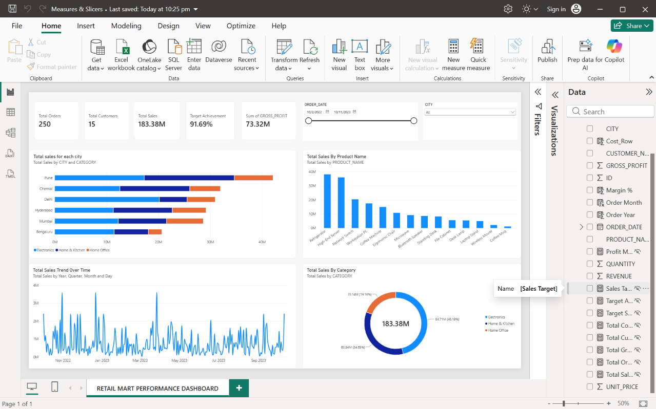

  - Created Measures are Hidden

